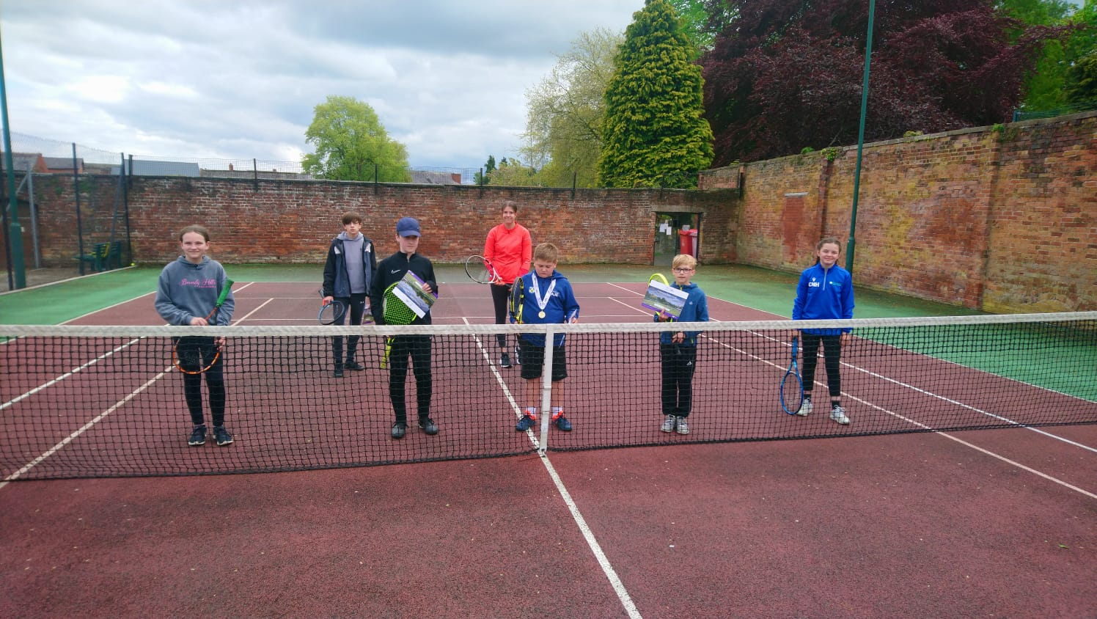Road to Wimbledon 2021 held at Oswestry Team Tennis for the first round of matches. We had 6 boys and 3 girls entered the competition, but sadly some of them ran off before the big photo. (Front Left to back right) Maisie Anderson, Elvis Clark, Alfie Edwards, Oliver Kielen, Catrin Hopkins, Sam Sperring, Jessica Persons-Hann. It was a great day’s tennis, with loads of happy faces on court and off, with parents safely socialising and enjoying the tennis. Jessica Persons-Hann won the girls part of the draw with Masie Anderson coming runner up. Alfie Edwards won the boys side of the draw, with Sam Sperring coming runner up. Both the winner and the runner up went through to the next round, held at The Shrewsbury Club on the 10th and 11th of July.

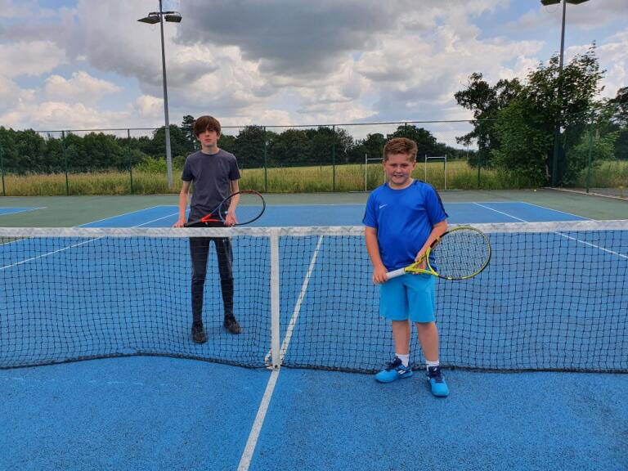

Sam Sperring and Alfie Edwards played once again at the county finals at The Shrewsbury Club, Sam went on to come 3rd winning 3 out of 4 matches and Alfie came 5th, so great performance by them.

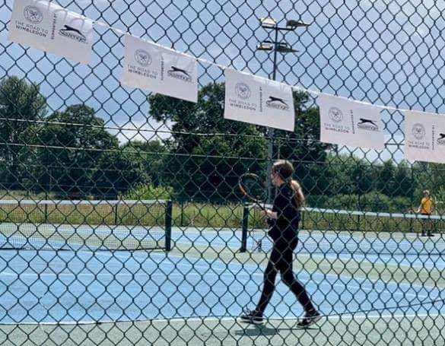

Here is Maisie Anderson playing one of her matches at the county finals at The Shrewsbury Club. She played two tough opponents, with one her matches going on for a very long time. She didn’t stop smiling and having fun, which is ace to see.

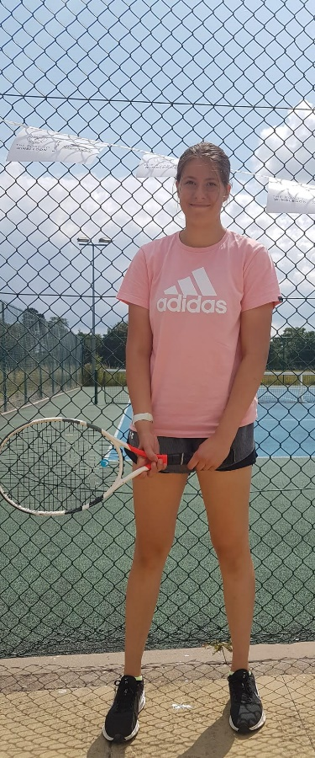

Jessica Persons-Hann after playing at the county finals at The Shrewsbury Club, she had a good performance and came 3rd overall.

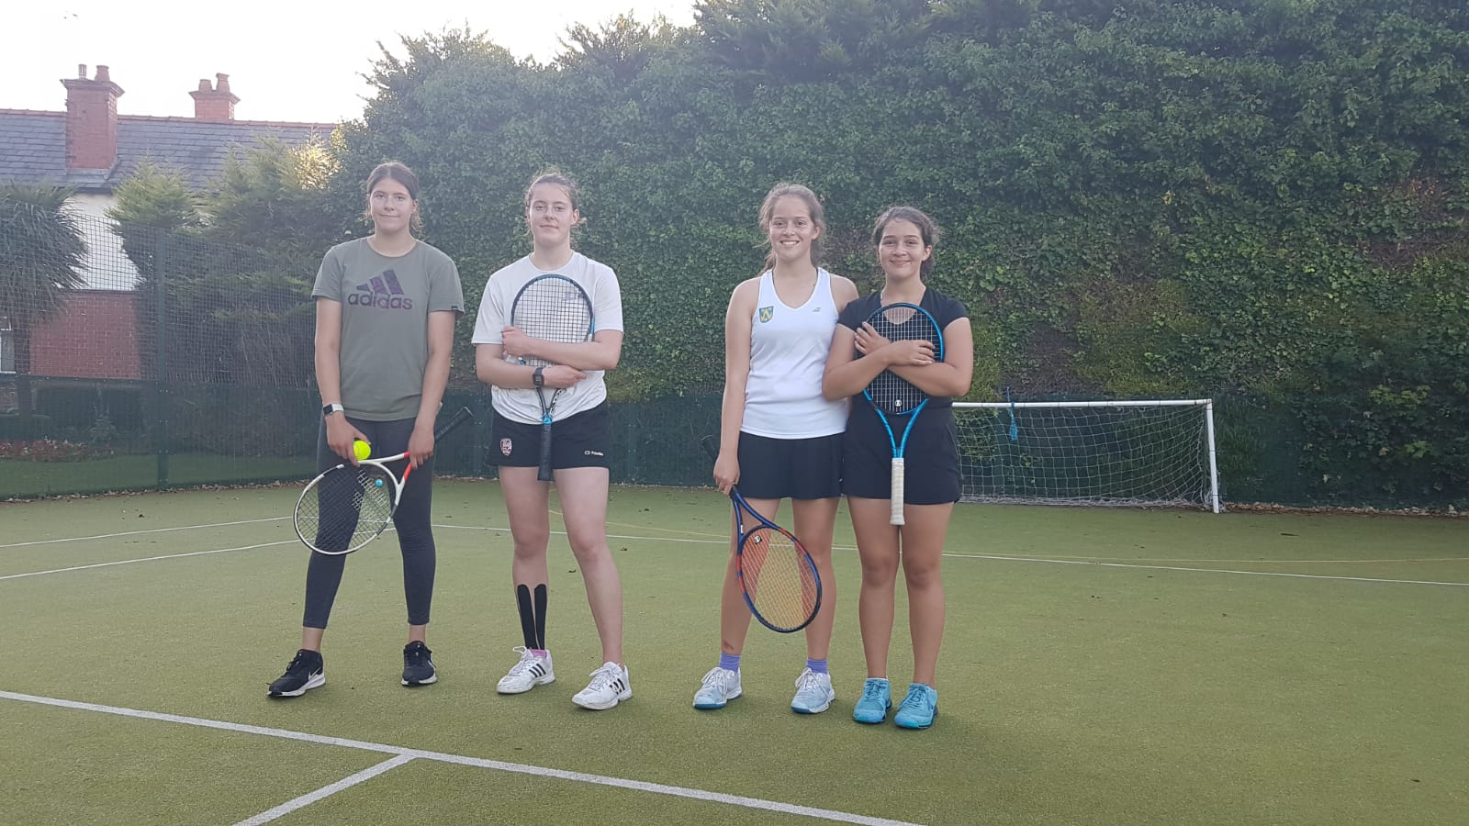

Jessica and Millie Persons-Hann (Left to Right) playing against Shrewsbury Pair Maisie and Lily Evans in the Aegon Girl’s National League 18 & under Shropshire division tournament match. Our girls played some great tennis sadly losing out in deciding doubles match, where it went to a deciding set. Great to see the sisters playing together.