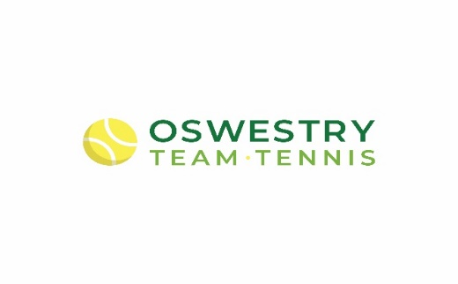

PAY AND PLAY ADULT TENNIS
Fancy learning some tennis, improving your skills or burning some calories???? Then our pay and play adult tennis is just for you, with our Rusty Rackets coaching every Tuesday morning and Cardio Tennis every Thursday morning, there is something for all. Please look below for more information on both pay and play sessions.

Rusty Rackets
Perfect for all stages of tennis. During these sessions you will learn different techniques and tactics of the game and put into practice in fun match plays.
Day: Tuesday
Time: 9:15am-10:10am
Cost: £6

Cardio Tennis
Great for getting fit and is suitable for anybody. During these sessions you will have fun, burn calories and hit a load of tennis balls to music.
Day: Thursday
Time: 9:15am-10:10am
Cost: £6

These sessions are separate to our other adult tennis programmes and both sessions are limited to maximum 6 per group and players must book 24h in advance in order to have a place. Payment is to be cash paid on day and please insure you bring the correct amount. Sessions run at Oswestry Team Tennis, Cae Glas Park and all our coaches are DBS certified, LTA qualified and First aid trained, and the club and coaches have adopted the LTA Child Safety Policy.

If you are interested and would like to find out more, please contact Tennis2You @ 07515 822921

See you on court
